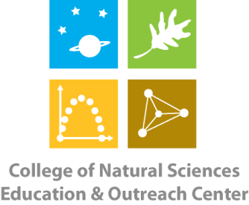
College of Natural Sciences
Education & Outreach Center
Colorado State University
B301 Natural & Environmental Sciences Building
Fort Collins, CO 80523-1802
970-491-1700
970-491-2005 - FAX

CNS Education & Outreach Center Soil Carbon STEM Kit Request Form

Requesting School/Organization:
Contact Name: Phone Number:
Email Address:
Check-Out Date: Return Date:

A classroom set (15 individual kits) of the Soil Carbon STEM kit* is available for checkout from the CNS EOC for teacher/workshop use. Each individual kit contains the following items:
- 1 Instruction Booklet
- 3 Jars of Soil Samples (marked A, B & C)
- 1 Scoop
- 1 Tweezers
- 1 Sieve
- 1 Large Petri Dish
- 3 Empty Vials (marked A, B & C)
- 3 Small Petri Dishes (marked A, B & C)
- 1 Mortar & Pestle Set
- 1 Digital Balance
- 1 Plastic Weighing Boat
- 1 Plastic Spray Bottle
- 1 Pipette
- 1 LED Flashlight
- 3 Site Photos (marked X, Y & Z)
- 1 Set of Colored Pencils
- Jar w/2 Wood Samples (burned and unburned)
*Teachers must provide students with microscopes and water as needed.
By signing below, I agree to handle the above materials with care and to return them to CNS EOC in the same condition as I checked them out in and by the above stated date (or earlier). I understand that if a piece of equipment becomes damaged or lost (unless it is a consumable) while in my care, I will be responsible for replacing it.

Signature Date

